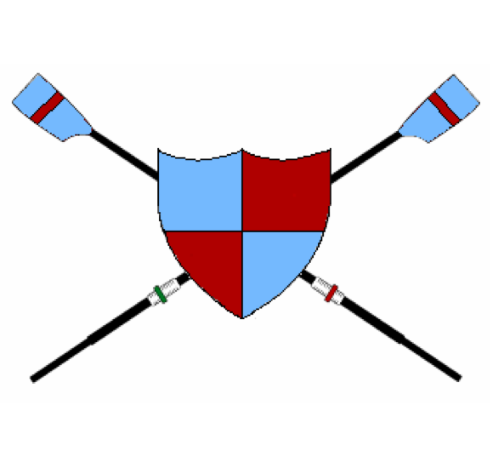

Lymington Amateur Rowing Club

Proposed Race Calendar 2024

Date | Event | Location | Comment
27th Jan 2024 | Weybridge Winter Head | Weybridge | All squads
17th Feb 2024 | Henley 4s & 8s | Henley | SLARC & Adult
25th February 2024 | Head of the Stour | Christchurch | All Club
1st March 2024 | National Junior Indoor Rowing Championships | London | Juniors only.
9th March 2024 | WEHORR | London | Eight only
16th March 2024 | Kingston Head | London
23rd March 2024 | BTC Spring HORR | Southampton | Small boats & 4s
22nd March 2024 | Oarsport Sculling Head | Eton Dorney Lake | Juniors
23rd March 2024 | HORR | London | Men’s Squad Only
24th March 2024 | Vets Head | London | Vets Eight
28th March 2024 | Schools Head | London | Junior Eight??
13th April 2024 | Southampton Coastal Fours HORR | Southampton | Adult squad
13th April 2024 | Mayflower Offshore race | Plymouth | FISA Offshore
20th April 2024 | Junior Interregional Champs | Nottingham | J16 downwards
27th April 2024 | Coastal Barbarians Offshore Race | Swanage | FISA Offshore
18th May 2024 | Milford Regatta | Milford | All Crews
25th May 2024 | Poole Regatta | Hamworthy Park, Poole | All Crews
25th May 2024 | Torquay Offshore Race | Torquay | FISA Offshore
1st June 2024 | Christchurch Regatta | Christchurch | J16 4+ & Adults/ SLARC
8th June 2024 | Ryde Regatta | Isle of Wight | J16 4+ & Adults/SLARC
9th June 2024 | Shanklin Regatta | Isle of Wight | J14 & 16 Quads & Adults/SLARC
15th June 2024 | Coalporters Regatta | Southampton | Adult/SLARC
21-23rd June 2024 | Women’s Henley Regatta | Henley | Ladies Crews?
22nd June 2024 | BTC Regatta | Weston Shore, Southampton | J16 4+, Adult & SLARC
29th June 2024 | Swanage Regatta | Swanage | All Crews
2nd to 7th July 2024 | Henley Royal Regatta | Henley | Blazer Time
6th July 2024 | Woolston Regatta | Weston Shore, Southampton | J16 Sculls and J16 4+, Adult/SLARC Crews
12-13th July 2024 | Henley Masters Regatta | Henley | Masters crews
13th July 2024 | Itchen Imperial Regatta | Southampton | J16 1x and J16 4+, Adult/SLARC
20th July 2024 | Southsea Regatta | Portsmouth | All Crews
3rd and 4th August 2024 | Newport 4s and Small Boats Regatta | Newport (Isle of Wight) | Adult, SLARC
10th August 2024 | Coalporters Junior Regatta | Southampton | Non-Champ and SLARC/JLARC
24th August 2024 | Dartmouth Royal Regatta | Dartmouth
14th September 2024 | South Coast Championships | Weston Shore | J14 and J16 4x+, Adult & SLARC
14th September 2024 | Carrick RC Offshore race | Falmouth | FISA Offshore
28th September 2024 | Exmouth Offshore Race | Exmouth | FISA Offshore
12th October 2024 | Teign Scullers Offshore Race | Teignmouth | FISA Offshore
26th October 2024 | Torquay Offshore Race | Torquay | FISA Offshore
End of Sept/ Oct. | Itchen Junior Regatta | Southampton | JLARC Only

N.B. For Offshore Beach Sprints details see - https://www.positivefloat.info/eventstable

